Let's discuss ways to improve our use of limited resources to remove barriers to learning. Some of the free services we provide to our students. Safety services for escorting individuals. Tutoring services to provide guidance in the unknown. Career Counseling to guide in making the optimal choice in careers. Our data on the impact of challenges life has to offer on learning provides insights into the needs of the student. Our findings suggest that concentrations of negative factors found in the data which represent challenges inhibit the success of the student. Let's explore the needs of our students.

Our institutional service to the community is to transform youth into adults. Our value comes from maximizing the number of people who can be transformed as well as the quality of transformation. It’s more than simply providing goals to overcome. Creating environments for successful growth has many facets to utilize. We cannot rely solely on traditional education. It's our duty to successfully develop new processes to assist in education. The activities that facilitate learning are more than just lectures. We can discuss ways of expanding our services to successfully increase the number of students who succeed. It's our mission to make all students walk these halls a successful alumni also able to become a functioning adult. Our data shows that 1027 of 1100 students surveyed have at least one high score that has a strong relationship with academic performance and of those who have a very high score in one is 657. Let's take a moment to consider the great challenges we face in improving the students' lives. Yet the human spirit is strong for having one score not significantly affect students' failure. A red flag emerges when we see students with 2, 3, 4 of these same high scores have the average of failure emerge. We might consider changes to these students' curriculum to include life management skills to further their success attendance.

The ritual of learning skills to be an asset to one of the many communities can be distributed by many distractions, lack of support, or needs of life. As these tools evolve to capture the attention of the student, so must we evolve to educate on life management. Our data of the students' life was found on the website of kaggle which is a repository of data to be used in the learning of data science. Its non-scientific grade meant more for learning the tools of data science. The first category measures the psychological factors. The data divided these into depression, having a mental health history, anxiety level and self esteem. The second category is ones of self care. The data divides these into headaches, blood pressure, sleep quality, breathing problems. Third category is the environment. The data divides these into noise level, living conditions, safety, and basic needs. The fourth category are those of academics. The data divides these into study load, academic performance, study load, teacher student relationship, future career concerns. The fifth category is social life. The data divide these into bullying, social support, peer pressure, extracurricular activities. Lastly, overall stress of the student which is the goal of the data to predict. I think it's more insightful to determine conditions where average academic performance drops to failing.

My Hypothesis is called critical interference. An individual is under so many distractions that they cannot make the necessary time in their life to conduct the ritual of learning. Let's use a story for example a poor student who has to work extra hours to support themselves that time not conducted learning the poor score of basic needs represents that event. Add in a history of mental health which is a useful proxy for an assumption of idea that cannot be measured directly of the mental habits of the poor student. And, add in bullying due to the students' lack of nice things from their poorness resulting in times spent in sadness, and we reflect on why the person has any time at all to pursue the act of learning.

Lets begin with a demonstration of the simple pattern underlying depression of a student and the group who share that same level of depression in the measured average grade. 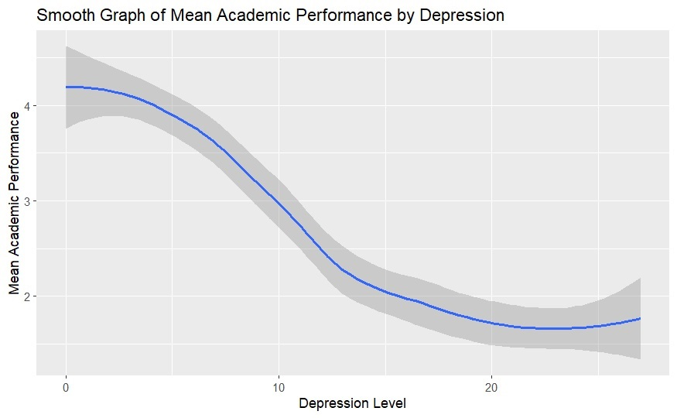As we increase the level of depression the average group rate decreases in an expected fashion for a factor that affects the ability to think. I observed the trend for all data in the set having this same basic trend with slightly varying strength, a factor that would start to interfere with learning. I argue the importance of addressing all variables measured in the data set, but that's not critical interference. Let's show the same graph further subdividing the groups into having a mental health history or not.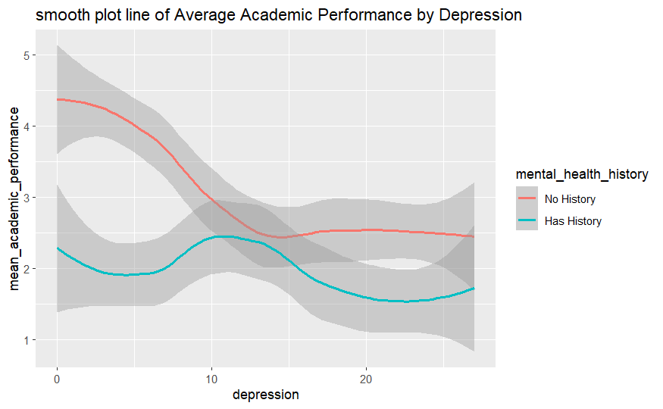

We see the group with two learning interruptions is always lower in grade average, and we can notice the slight increase in the average grades of those who have no history across the spectrum of depression. In the upper range 20 to 30 we start to see the average drop below one which is sufficient for a student to start failing at the university. Critical interference is about all possible combinations of the factors that interfere with grades. The depression effect on the brain is all the worrying exhausted the students. It zaps of the student of the will to continue the struggle to learning.

Lets see for anxiety with the history split again to show the similar pattern emerges. 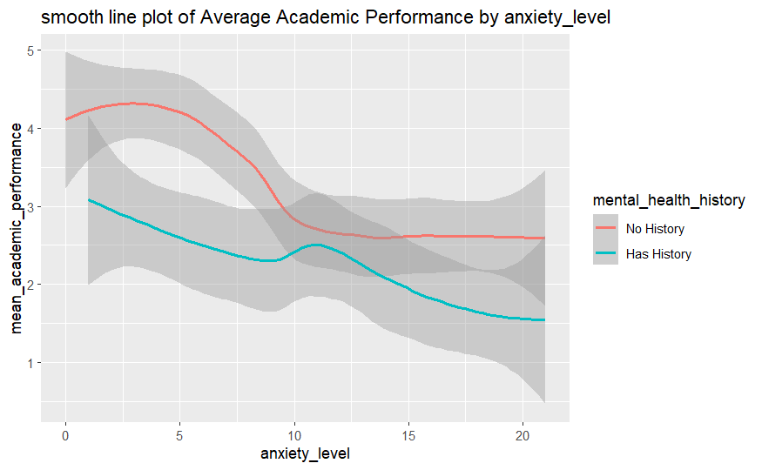

Anxiety the flight response interferes with learning by preventing a person from retaining information. The anxiety responses produce a distraction for the student. It also affects short term memories. The last part of the problem of anxiety is avoiding the tasks at hand i.e wasted time that could be dedicated to learning. It's no surprise that we see the same trends for anxiety and depression with the same decrease in mental health history.

Using the poor student story, let's show basic needs which are a measure of the students wealth or time they have to spend working. To keep showing the difference between one factor in the high scores and two factors, I split the groups by mental health history. The pattern is not as clear cut, but again the low scores have a concentration of poor grades.

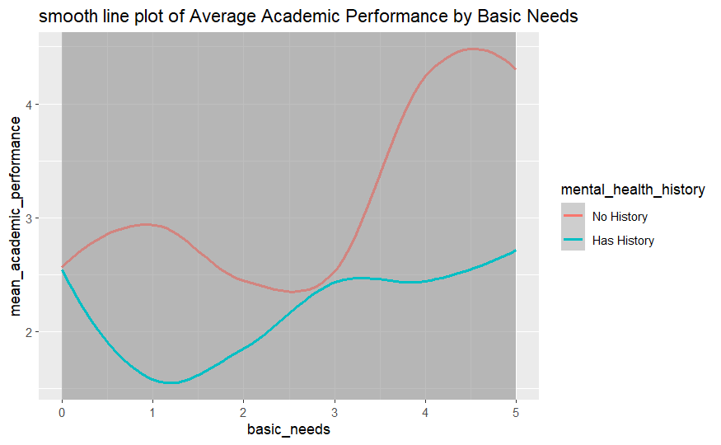

We have the same trend lines and the save averages emerge from the graph. Let filter for anxiety and depression by filtering the group to have high depression and then graph the anxiety levels separated into two groups.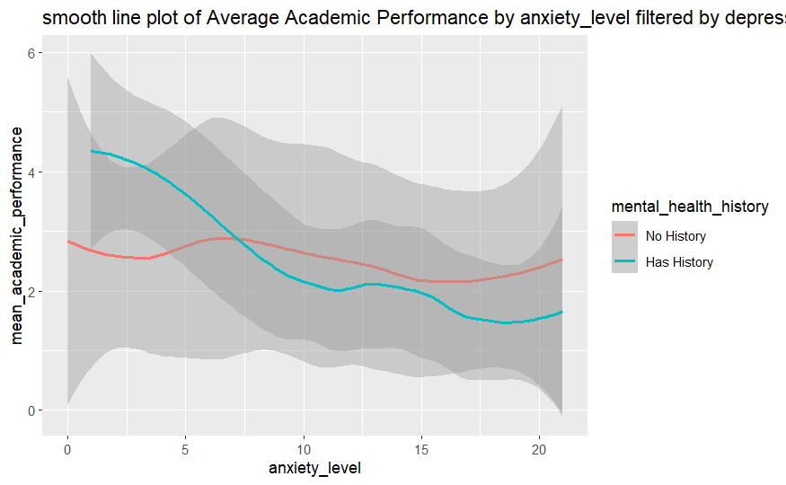as we increase the interference further from two factors to three factors that affect learning the same pattern emerges. Critical interference, the concentration of a low average of a group with high scores in our measures in the data, occurs at the emergence of two factors, but works for three and so on.

In conclusion, life is full of difficulties and our mission to make every student a successful student comes from the reduction of challenges they face. Reducing the severity of these factors will improve our grades and the chance that students will succeed. Watching out for concentrations of lifes challenges in the students can be incorporated into our academic routines of education. Helping people live life better is part of achieving that goal.

The recommended course of action is to add CBT therapy to part of the core curriculum. Helping students understand the mental habits and the impact of their life. According to the therapy, the habits of the mind make the emotional states we are in. CBT therapy teaches us that by simply addressing the habits of the mind we can break their power over our actions. Due to lack of mental health education and the sigma of the practice, we have much to gain in improving the students ability to fight habits of feeling of worthlessness, feeling of inability, ect. Now we understand critical inference we can now address the problem improving our ability to keep students and the weakness in the curriculum.